TEMA 1:

In English, `[clear l] and [dark l] are two allophones of /l/ that appear:

* In free variation.
* In the same context
* **In complementary distribution.**

When two allophones of the same phoneme are in free variation, they appear in...

* Mutually exclusive contexts.
* **The same context.**
* Different contexts.
* Contrastive contexts.

A checked syllable…

* Has a zero onset.
* **Ends in a consonant.**
* Ends in a vowel.
* Has a zero coda.

The peak of a syllable…

* **Is always a voiced sound.**
* Is not a compulsory element.
* May be unvoiced.
* Is always a vowel.

In a syllable, the coda includes…

* The consonant(s) that precede(s) the nucleus.
* **The consonant(s) that follow(s) the nucleus.**
* The vowel and the preceding consonants.
* The vowel and the following consonants.

Which of the following features is not a suprasegmental feature?

* **Aspiration.**
* Accent.
* Stress.
* Intensity.

Two sounds are in complementary distribution if they appear…

* **In mutually exclusive contexts.**
* Next to each other.
* In the same context.
* In a minimal pair.

A minimal pair consists of...

* Two words with the same number of letters.
* Two sounds with the same characteristics.
* **Two words differing in only one sound.**
* Two different sounds.

In an English coda…

* Only one consonant is possible.
* **We may find up to 4 different consonants.**
* We may find up to 3 different consonants.
* Any consonant combination is possible.

A syllable rhyme includes…

* The onset, the nucleus and the coda.
* **The nucleus and the coda.**
* The onset and the coda.
* The onset and the nucleus.

The .... is/are the only compulsory element(s) of the syllable…

* Onset.
* Coda.
* Nucleus and coda.
* **Nucleus.**

An open syllable…

* Has no initial consonant clusters.
* **Has no final consonant clusters (grupo).**
* Has a zero onset.
* Has a voiced coda.

Which of the following pairs of words constitutes a minimal pair?

* / sæd, kæt /
* / pen, tæn /
* **/ friː, triː /**
* / laʊd, rəʊd /

English allows a maximum of ... consonants at the beginning of a syllable and usually a maximum of ... at the end.

* 2/3
* 1/3
* **3/3**
* 3/4

TEMA 2:

Which of the following terms is not a place of articulation?

* Dental.
* **Approximant.**
* Velar.
* Palatal.

Affricate sounds involve the combination of a .... manners of articulation.

* Fricative + plosive
* **Plosive + fricative**
* Fricative + approximant
* Plosive + approximant

What is clipping?

* **The shortening in the duration of a vowel that precedes a voiceless sound**
* The shortening in the duration of a vowel that precedes a voiced sound
* The lenghthening in the duration of a vowel that precedes a voiced sound
* The lengthening in the duration of a vowel that precedes a voiceless sound

In the production of voiced fricatives

* **The vocal folds are close together**
* The vocal folds are abducted
* The vocal folds produce friction
* The vocal folds do not vibrate

For the production of voicelessness, the vocal folds are...

* **Abducted**
* Adducted
* Closed
* Vibrating

For the production of creaky voice, the vocal folds are...

* Slightly open
* **Slightly open at one end and completely closed at the other**
* Apart
* Completely closed

The words rope / rəʊp / and robe / rəʊb / are distinguished in English by the...

* Manner of articulation of the last consonant
* **Voice of the last consonant**
* Place of articulation of the last consonant
* Orality of the last consonant

The tongue, the lips and the soft palate are…

* Primary articulators
* Secondary articulators
* **Active articulators**
* Passive articulators

Nasals are produced with a(n) ... of the articulators in the oral cavity.

* Partial closure
* Narrow approximation
* **Complete closure**
* Open approximation

With which airstream mechanism are English sounds produced?

* Pulmonic with air flowing inwards
* Glottalic with air flowing inwards
* Velaric with air flowing outwards
* **Pulmonic with air flowing outwards**

In the production of voiceless fricatives…

* The vocal folds are adducted
* **The vocal folds are separate**
* The vocal folds produce friction
* The vocal folds vibrate

Which of the following groups of consonants only contains voiceless fricatives?

* / ð f h /
* **/ ʃ θ h /**
* / ʒ ʃ s /
* / h tʃ f /

In the production of labio-dental sounds…

* **One articulator is passive and one is active**
* The two articulators are active
* The two articulators are passive
* The two articulators move

Which of the following terms is not an airstream mechanism?

* Velaric
* **Velic**
* Glottalic
* Pulmonic

TEMA 3:

English vowels /ɒ/ and /ɑː/ are…

* Open-mid and rounded
* **Back and open**
* Back and rounded
* Open and tense

Which of the following pairs of diphthongs does **not** contain a centring diphthong?

* / eə aʊ  /
* **/ eɪ əʊ /**
* / ʊə aɪ /
* / ɔɪ ɪə /

Which is the common feature of the following English vowels / ɑː, ʊ, ɔ / ?

* Rounded.
* **Back**
* Open
* Tense

Which features are common to the following vocalic sounds / iː, æ, e / ?

* Close and rounded
* Open and unrounded
* Central and unrounded
* **Front and unrounded**

/ ɜː, e, ɔː / are ..... vowels.

* Back
* Central
* Open
* **Half-open**

Which of the following groups of vowels does **not** contain a back vowel?

* / ə  æ ɒ /
* / ɪ ɑː iː /
* **/ æ ʌ ə /**
* / uː ʊ ɪ /

Which of the following features is common to vowels / ʌ / and / ɜː / ?

* Open
* Tense
* Rounded
* **Central**

Which of the following sets of sounds does **not** contain a back vowel?

* **/ɜː, æ, ʌ/**
* / e, ɪ, ɒ /
* / ɑː, ə, e/
* / uː, iː, ɜː /

Which of the following parameters is **not** used to describe vowels?

* Lip posture
* Tongue position
* Tongue height
* **Tongue constriction**

English vowels /ɜː/ and /ə/ differ in

* Quantity and quality
* Quantity only
* Lip rounding
* **Quantity only**

English vowels /ɒ/ and /ɑː/ are

* Open and tense
* **Back and open**
* Open-mid and rounded
* Back and rounded

TEMA 1, 2 & 3:

Which of the following terms is not a syllable constituent?

* Nucleus
* Onset
* Coda
* **Offset**

FINAL TEST MAY:

In English, speech sounds are produced...

* When the diaphragm contracts
* On an ingressive airstream
* **When the chest contracts**
* When the chest expands

Phonologically, vowels are characterised by...

* The OBR labels
* Having no obstruction in the vocal tract
* **Their intonational prominence**
* The action of the vocal folds

For the production of a nasal sound....

* **The velum is lowered**
* The velum is raised
* The glottis is open
* The vocal folds do not vibrate

The phonemes / l, r, j, w / are described as...

* **Approximants**
* Glide consonants
* Lateral approximants
* Central approximants

The four phonemes /f, v/ and /ʃ, ʒ/ have as a common feature ....

* **The manner of articulation**
* The place of articulation
* The force of articulation
* The position of the vocal folds

Which of the following is the object of study of Phonetics?

* The features which extend over more than one segment
* The coarticulation of phonemes in alliteration
* **The descriptions of sounds and their classification**
* The paradigmatic relationships between phonemes

For the production of voice, the vocal folds are...

* **Adducted**
* Held wide apart
* Abducted
* Not vibrating

The difference beyween /z/ and /d/ is based on ...

* **Manner of articulation**
* Manner and place of articulation
* Voicing
* 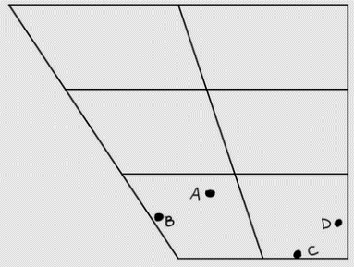Place of articulation

Which of the four positions shows the correct location for the vowel sound in the word 'sun'?

* B
* **A**
* C
* D

The syllable /ˈɑːskt/ is...

* Minimum
* 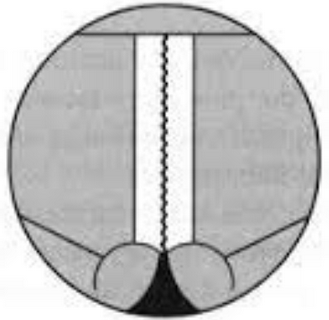Long
* Open
* **Checked**

This diagram represents...

* **Breathy voice**
* Whisper
* Creaky voice
* Modal voice

Which of the following is not a possible syllabic pattern in English?

* **CCVCCCC**
* CCVCCC
* CCCVCCCC
* CCCVCC

The vowel which is described as "between close-mid and open-mid, central, neutrally spread, tense and long (free)" corresponds to the phonetic symbol...

* /ɑ:/
* **/ɜː/**
* /uː/
* /ɔː/

Allophones...

* **Exhibit phonetic similarity**
* Stand in contrastive distribution
* Are limited in number
* Entail a change in meaning

The difference between /e/ and /æ/ is related to:

* Lip shape
* **Tongue height**
* Tongue backness
* Muscular energy

Aspiration of RP fortis plosives takes place ...

* In syllable-final positions
* In syllable-initial positions
* In unstressed positions
* **In syllable-initial stressed positions**

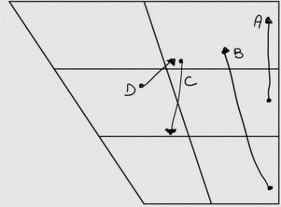Which of the four articulations represented in the vowel chart corresponds to the vowel sound in the word 'old'?

* A
* B
* C
* **D**

A phoneme is...

* A variant of a phone
* A realisation of a phone
* **An abstract segment**
* A single phonetic segment

Cardinal vowels...

* Illustrate the sustained quality of English vowels
* Illustrate transitions and glides
* Are 8 of the 12 English vowels
* **Reflect extreme tongue positions**

What are the obligatory elements in zero onset syllables?

* **The nucleus**
* The nucleus and the coda
* The onset and the nucleus
* The coda

The diphthong / eɪ /  is ________  than / ɔɪ /.

* Wider
* **Narrower**
* 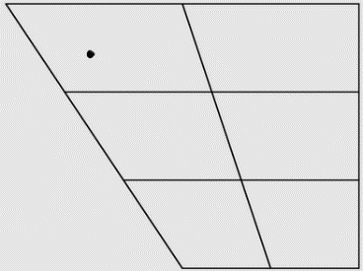More centring
* More closing

The position marked in the trapezium corresponds to...

* A close-mid, back, lax vowel
* A close, back, tense vowel
* **A near-close, near-front, lax vowel**
* A close, front, tense vowel

A sonorant consonant that becomes the peak of a syllable is called...

* **Syllabic**
* Reduced
* Linking
* Nuclear

The inflectional ending ˂-ed ˃ for past tenses and past participles of regular verbs is affected by ...

* The length of the previous sound
* **The voicing of the previous sound**
* The lip position of the previous sound
* The stress on the final syllable

Pre-fortis clipping is a process that affects ...

* The quality of a long vowel
* The length of a short vowel
* The quality of a short vowel
* **The length of a long vowel**

Which of the following words shows a case of clipping?

* Girl
* Month
* Drank
* **Heart**

Which of the following words shows a case of lengthening?

* **Call**
* Old
* Odd
* Cot

Which of the following words is the odd one out regarding the stressed vowel?

* Fool
* Luke
* **Foot**
* Food

Which of the following words is the odd one out regarding the stressed vowel?

* Reach
* Thief
* People
* **Build**

Identify the pair of homophones

* I’ll, ale
* **I’ll, aisle**
* Aisle, ale
* Aisle, ail

Another answer could be: ale, ail